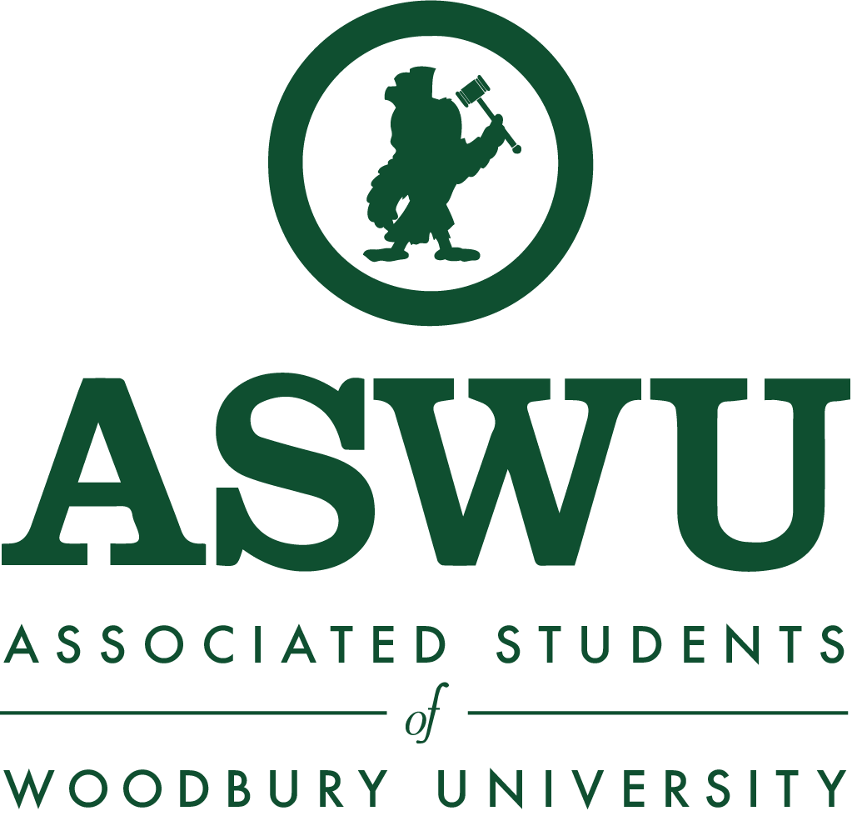
Assembly Meeting Agenda
Monday, October 21, 2019
12:00PM - 1:00PM
Saffell Boardroom

Call to Order 12:02pm

12:00PM - 12:05PM Attendance

12:05PM - 12:20PM Guest Speaker

12:20PM - 12:25PM Announcements/Upcoming Events
- Phi Sig
  - Sister auction
  - Woody's patio
  - Raising money for burbank arts foundation for children
- BSA
  - BombFire
  - Dockwiler beach
  - 4-10pm

12:25PM - 12:35PM Open Forum
- If you have anything that was not addressed, please submit an anonymous comment into the Comment Box right outside in the hallway, in the pool house, or via our virtual comment box on our website: aswu.woodbury.edu.
- Mariah has not informed ppl
- Marketing Tips
- Complaints about Miller Hall
  - Wants extended hours
  - Not Open 24 hours
  - Updates are coming soon
  - Bringing it up to IT
  - President has meeting with IT this Thursday
  - People are walking through classes and interrupting
    - Can get class schedules on doors, to try to prevent it.
- Vending Machines
  - By the Laser Lab are still not working

12:35PM - 12:45PM Senator Reports
School of Architecture
- Lorena Mendoza
  - I met with INgalil last week and have started to set many projects in motion.
  - This week I will be meeting with Catherine
  - Setting a meeting with the Head of Departments
- Erika Shipcott
  - (working together, same report)
School of Business
- David Manikad
- Melissa Toribio
  - Hello everyone! I am glad to be apart of the senators this semester!
  - I am still in the process of scheduling meetings with Joan and the department chairs for the upcoming week.
School of Media, Culture, and Design
- Jonei Battle
  - I have a meeting scheduled with the film department to talk about improvements and the computer lab.
    - November 7th
  - Also I have met with Anna to talk about getting more recycling bins in the fashion department.
  - Scheduled a meeting with Animation
- Emmanuel Adewuyi
  - I have received complaints about the women’s bathrooms in the Design Center being unsanitary
    - There are a lot of bugs.
    - Housekeeping cleans, but there is toilet paper all over the place by the middle of the day.
    - In the ADA stall, you can easily stand and see into the stall if you are tall.
College of Liberal Arts
- Gayane Mikaelyan
  - (no report)
- Meline Safaryan
  - Hey guys!
  - Not too much to report but I I had a conversation with Rueben Ellis about a game night event for COLA students.

12:45PM - 12:55PM Executive Board Reports
- William Garcia, President William.garcia@woodbury.edu
  - Thank You for going to Discover Woodbury!
    - 600+ people showed up.
  - Lunch or Pizza with the President
    - Date TBD
  - Elections
    - Next semester mid-late February
    - Executive boards positions
  - No big updates
    - Thank you to everyone who attended Discover Woodbury, it was a huge event, turned out to be really successful.
- Marta Huo, Executive VP Marta.huo@woodbury.edu
  - Hello everyone hope all is well
  - We are slowly getting ideas together for the drop off canopy and we are hoping to get students involved in the designing process
  - So if you or anyone else have any ideas please feel free to let me know
  - Thank you
- Veronia Alkomos, VP of Finance Veronia.alkomos@woodbury.edu
  - Late Reconciliation:
    - Zone V: Picture Day
    - Phi Sigma Sigma
    - CEO Breast Cancer Awareness
    - All new orgs please contact mevPhi Sigma Sigma: Color Run
    - CEO: Breast Cancer Awareness
  - Reconciliation Due:
    - Animation Club: Wilderness Explorer Scavenger Hunt on Oct 23rd
    - All Spirit Week Tabeling on Oct 31st
  - For all the new Orgs please contact me so I can help you with your future OAC events and explain seed money.
  - Also please let me know 2 weeks in advance if you’re adding an event, removing an event, or changing date, time, location of an event.
- Matthew Pardini, VP of Marketing Matt.pardini@woodbury.edu
  - Hello
  - Tabling was awesome. A lot of people came out!!!
  - Links are updated on the website. I’ll be working on getting the small things updated from here on out
  - Working on winter swag now!
  - That’s all I have for now
- Marina Castillo, VP of Student Orgs Marina.castillo@woodbury.edu
  - Logistics for Org Storage space is being worked out. Will give more updates once i have them.
  - Greek Council
    - Will be emailing every greek member with info about forum. It will be on October 30th from 12-1pm. Will be in the design center. More info will be emailed.
    - This is for everyone interested in renewing Greek Council. We will be reviewing the new constitution that i am currently drafting.
  - Hope everyone is doing well, reach out if there are any questions, comments, or concerns
- Melissa Castillo, VP of Student Life Melissa.castillo@woodbury.edu
  - Atmosphere
  - Spooktacular
    - C&GI
    - Next Thursday on Oct. 21st
  - CAB and Get It on Wednesday
  - WINTERFEST
  - LNB
    - Dec 1st 10pm-10am

12:55PM - 1:00PM Advisor Report
- When an event is off campus , please remember that we are representing Woodbury.

Next Meeting
- Monday, October 28th, 2019, 12:00PM-1:00PM, Saffell Boardroom
Adjourn 12:26pm

