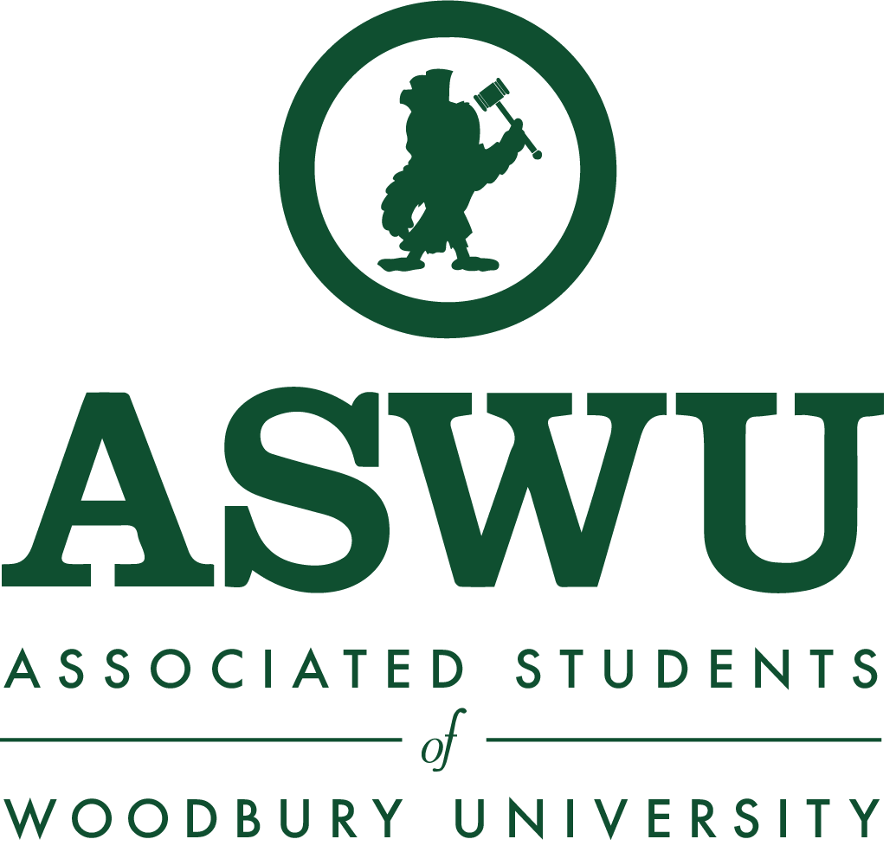
Assembly Meeting Agenda
Monday, November 4, 2019
12:00PM - 1:00PM
Fletcher Jones Auditorium
Call to Order 12:01pm

Moment of Silence for Malik Peterson

12:00PM - 12:05PM Attendance

12:05PM - 12:20PM Guest Speaker

12:20PM - 12:25PM Announcements/Upcoming Events
- Wednesday 11/6
  - CEO is having a workshop for elevator pitch
    - 12:20pm -1pm
    - Business building 209
- Moria first press reading
  - Nov. 11 12pm -1 pm
  - Open mic
  - Free Food
  - Located in the Ahmanson
- CEO
  - Creative minds conference
  - Needs help advertising
- BSA
  - Thank you to everyone who came out to zombie run.
- Last Assembly Meeting
  - Nov. 18 will be our last Assembly meeting
  - President Steele will be attending
  - We will be providing free food and drinks

12:25PM - 12:35PM Open Forum
- If you have anything that was not addressed, please submit an anonymous comment into the Comment Box right outside in the hallway, in the pool house, or via our virtual comment box on our website aswu.woodbury.edu.

12:35PM - 12:45PM Senator Reports
School of Architecture
- Lorena Mendoza
  - We have reached an agreement of the department surveys and will be working with Erika to distribute the survey throughout the department.
  - QR code will be given out
  - FREA stamp should be on the flyers
  - Arch town hall meeting is postponed
- Erika Shipcott
  - Meeting with Christoph (chair for the department) again this week.
School of Business
- David Manikad
  - (no report)
- Melissa Toribio
  - (no report)
School of Media, Culture, and Design
- Jonei Battle
  - Meeting scheduled on Nov 7
    - With George Larkin
- Emmanuel Adewuyi
  - (no report)
College of Liberal Arts
- Gayane Mikaelyan
  - Hello Everyone!
  - We’re working with Rouben Ellis on the COLA instagram.
  - Haven’t gotten to speak with him these past weeks due to midterms.
  - Thank you!
- Meline Safaryan
  - (no report)

12:45PM - 12:55PM Executive Board Reports
- William Garcia, President William.garcia@woodbury.edu
  - ASGA conference in Dallas over the weekend
    - Workshops to see how other student governments work
    - To see what we have been doing right and what we can improve on
    - We are currently taking some time to discuss and reflect the information we learned
  - Malik Peterson
    - Visual for him
    - Will update you guys once we get more information
  - Nov 21st
    - 12-1
    - Turkey Carving
- Marta Huo, Executive VP Marta.huo@woodbury.edu
  - Hi everyone
  - Eboard just got back yesterday from ASGA in Dallas
  - We got a lot of ideas about future projects, swags and learned a lot of new student government information
  - We will be making some changes in the near future
  - Also thank you to everyone that participated in the zombie run especially my interns and BSA
  - The turn out was awesome and thank you to the interns for helping and running the event
- Veronia Alkomos, VP of Finance Veronia.alkomos@woodbury.edu
  - Late Reconciliation
    - Zone V: Picture Day
    - Phi Sigma Sigma: Color Run
    - CEO: Breast Cancer Awareness
    - 7500 Club: Spirit Week
    - Beta Lambda Chi: Spirit Week
    - BSA: Spirit Week
    - BPWOW: Spirit Week
    - CEO: Spirit Week
    - Phi Sigma Sigma: Spirit Week
    - Sigma Omega Nu: Spirit Week
    - Zone V: Spirit Week
    - Accounting Society: Spirit Week
  - Reconciliations Due
    - AIAS: Stressbusters 1 → Nov 4th
    - AIGA: Flutter Museum → Nov 6th
    - BSA: BSA Bonfire → Nov 8th
- Matthew Pardini, VP of Marketing Matt.pardini@woodbury.edu
  - Hello!
  - ASGA conference
    - Getting ASWU name out there
    - Want to educate the student body what ASWU is rather than just give out swag without branding on it
  - SWAG and table clothes will be ordered this upcoming week hopefully
- Marina Castillo, VP of Student Orgs Marina.castillo@woodbury.edu
  - Moving forward with Officer applications for Greek Council
    - Apps due Nov. 13.
    - Can turn them in to me after if you have them.
  - Meeting with La Voz Unida President to get a progress update.
  - I’m thinking about implementing a couple of workshops like officer transitioning and president roundtables for Spring semester.
  - Let me know if there are any suggestions.
- Melissa Castillo, VP of Student Life Melissa.castillo@woodbury.edu
  - Thank you to everyone who came to Spooktacular
    - It was our first one and we had a lot that we wanted to do in a short set up period, so that is one thing that the next group will be taking into consideration
  - NACA
    - Nov. 14-17th in Ontario
    - Will be looking for potential Woodstock talent
    - You guys will not know until April next year
  - Winter Fest
    - November 21st
    - Soups and “How the Grinch Stole Christmas”
    - Org set up is at 6:30pm
    - Alumni quad
  - Late Night Breakfast
    - Dec 4th
      - We are doing the food truck from last semester
        - Asking if the company has two food trucks that we can have on campus to diminish the line so students can get back to studio faster

12:55PM - 1:00PM Advisor Report

Next Meeting
- Monday, November 11 2019, 12:00PM-1:00PM, Saffell Boardroom
Adjourn 12:20 pm

